Chapter 7 Constellation Innovation
7.1 Technical and commercial factors determining and driving constellation innovation.
We ended the last chapter by stating that a combination of technical and commercial factors are reducing the per bit delivery costs of the satellite industry. Technical factors include launch innovation, satellite innovation and antenna innovation. Commercial factors include lower insurance costs, a by-product of improved launch reliability and longer in orbit service life, multiple payload protocols and most significantly, an infusion of cash and equity from companies such as Google, Apple, Facebook and Amazon. Twenty years ago these companies either did not exist (Facebook) or were being started (Google) or were less than 4 years old (Amazon) or only just emerging from a period of losses. (Apple).
In this chapter we cover a number of companies that are either newly formed or that are at most four to five years old with ambitions to build satellite constellations at a scale previously attempted (Teledesic and Skybridge) but never achieved.
The scale of these constellations is important because this determines their economic viability but as covered in previous chapters, high count constellations also mean that satellites are nearly always nearly overhead. This minimises latency and improves the link budget and makes it more likely that connections with terrestrial users and devices will be clear line of sight, minimising scatter loss and surface absorption. This is particularly important for the higher end centimetre bands and millimetre bands. High count constellations can also take advantage of the capabilities of active electronically steerable (AES) arrays on terrestrial platforms such as cars and trucks. Advanced implementations of AES arrays are capable of horizon to horizon scanning for satellites providing the most favourable link budget. For example if a preferred signal from a directly overhead satellite is blocked then a satellite lower in the sky can provide alternative connectivity.
The point of constellation innovation can be summarised as
Make Satellites Do More – For Longer- At Lower Cost
This includes techniques for increasing service life, for example through improved hardware (processors, memory and solar panel arrays), in orbit servicing and hardware upgrades and repairs and optimised station keeping. Low earth orbit satellites, particularly lower orbit LEOS, have a small amount of atmospheric drag and can be pulled off station by changes in the near earth gravitational field. Station keeping is therefore a continuous task that absorbs power and in the past has been an important factor determining end of life, for instance due to expended hydrazine.
Solar panel ion thrusters have helped but also optimised ground based control of satellites both in terms of their altitude and attitude (pitch and yaw control) have resulted in an extended service life. For example the first generation of Iridium satellites launched in the 1990’s had an expected life expectation of seven years but the constellation remained fully functional for twenty years and is only now being replaced. It has also been traditional practice to have a core of operational satellites with some back up satellites that are either kept in an interim orbit or kept ready for rapid launch. Remember that it only takes twenty minutes to get into space, faster than driving a truck to a base station site in rush hour (though more fuel will be used on the journey).
More recently, constellation design has embraced the concept of autonomous self-drive satellites that manage their own station keeping independently of any earth based network control. This theoretically at least reduces earth to space signalling overhead and could be potentially more power efficient. Cube SATS over their 15 year implementation history (the first Cube SAT was launched in 2003) have moved towards this model of autonomous or semi-autonomous control though there are related regulatory issues (such as debris limitation and avoidance) that need to be accommodated.
7.1.2 A reminder of the constellation options
First a reminder of the constellations options including the spectrum options (excluding VHF) Table 7.1, orbit options (excluding Quazi zenith and high elliptical orbits) Table 7.2 and size (including Cube SATS) Table 7.3
Table 7.1 Satellite spectrum options
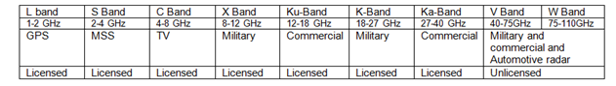
Table 7.2 Orbit options
Table 7.3 Satellite size options
In terms of commercial constellations and excluding for the moment Cube SATS that will be covered later, there are four distinct sectors that need to be considered
NEWLEGACYLEO
These are companies such as Orbcomm (VHF) and Iridium (L band) and Globalstar (L band and S band) that have either upgraded their constellations (Orbcomm OG2 and Globalstar) or are in the process of upgrading (at time of writing Iridium had successfully launched 30 Iridium NEXT satellites on three Space X rockets). Services include IOT and voice connectivity and positioning, location and collision avoidance. These constellations are in polar orbits and provide coverage at all latitudes including obviously polar regions where GSO to terrestrial connectivity becomes problematic.
NEWLEGACYGSO
These are companies such as Inmarsat and Intelsat and all the other SATS with geostationary satellites providing a range of broadcasting and two way data and voice services. Note that geostationary is not the same as geosynchronous. Geosynchronous satellites are satellites that are rotating at the same speed as the earth but are not positioned over the equator. They are sometimes described as quasi zenith (QZ) constellations and will usually produce a defined parabolic footprint over a defined geographic area. The new Mitchibiki GNSS constellation in Japan is an example.
These constellations are significantly different in terms of their spectrum and available bandwidth. The Orbcomm VHF constellation has a 1MHz+1MHz pass band at VHF, Iridium and Globalstar have a 10MHz+10 MHz pass band with an additional 7MHz for Globalstar in S band. The NEWLEGACYGSO high thoughput satellites have 3.5 GHz pass bands at Ku, K and Ka- band combined with L band, S band and C band transponders. The satellites scale from 170 kilogrammes for an Orbcomm LEO satellite to 6000 kilogrammes for an Inmarsat or Intelsat GSO which means that they scale from tens of watts to hundreds of watts to kilowatts in terms of available power.
There are of course opportunities to exploit these differences to combine the performance benefits of each option, for example a robust link budget with Orbcomm but limited bandwidth but with other capabilities such as positioning and location and good coverage at high latitudes . Similar functionality is available from Iridium and Globalstar though with additional bandwidth. The NEWLEGACY GSO’s with their 15 kilowatts of solar power and 3.5GHz+3.5 GHz of Ka-band spectrum hold the high throughout trump cards but have the longest latency, long path lengths through the atmosphere at higher latitudes and a vulnerability to building and foliage blocking at higher latitudes.
Sometimes launch failures or partial failures where satellites fail to reach their final orbit or lose RF power prompt interworking agreements. Orbcomm for example has had a number of satellite failures as part of their OG2 constellation upgrade with almost a third of the constellation (ten out of 31 satellites) compromised either by a failure to achieve final orbit or hardware or software failures. At a book value of $10 million dollars per satellite this is a frustration though not unknown or even particularly unusual in the satellite industry. The insurance was for launch and one year in orbit and therefore the satellites with hardware and software failure must be written off. The technical and commercial solution has been to couple the service proposition to Inmarsat’s I-4 GSO L band service offer and to reposition the surviving fully operational OG2 satellites to optimise high latitude coverage. The decision was also taken to develop modems which could combine OG2 service with Inmarsat4(L band) and terrestrial cellular, initially AT&T and Verizon, T –Mobile, Orange, Telefonica, Vodafone and Rogers (Canada)
The remaining OG2 satellites produce a longer gap than originally intended between passes which results in connection latencies of several minutes (which of course is often not a problem for IOT connectivity). At higher latitudes, users connect with the Inmarsat I-4 with a latency of around 15 seconds (a consequence of available bandwidth rather than visibility constraints. Note that fairly obviously a GSO constellation can have visibility at higher latitudes if users are at high altitude.
From a customer’s point of view the end result will be similar to the original constellation plan.
As covered in Chapter 2, Orbcomm’s customers include vendors of high value large mobile machines, monster tractors and mining machines, diggers and generally devices that dig very large holes in the ground and a few ships and oil and gas rigs as well with enough capacity now available from the combined LEO and GSO and cellular service offer to move into more mass market telematics. A potentially catastrophic combination of launch failure and hardware and software failure in space has had a minimal impact on Orbcomm’s customers and little obvious impact on the growth and profitability of Orbcomm which proves the point that a mixed constellation approach combined with terrestrial cellular is probably the way ahead for many space and terrestrial service providers.
Figure 7.1 Orbcomm modems for VHF, L Band Inmarsat-4 and terrestrial cellular
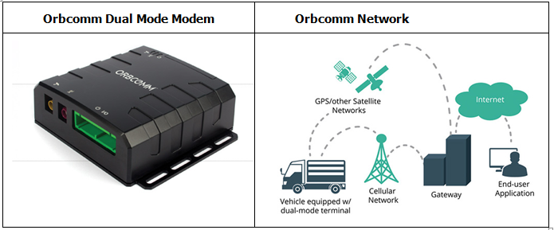
Inevitably scale issues associated with developing and manufacturing modems for specific network combinations imply a cost issue particularly as the satellite networks have different physical layers in different bands requiring bespoke RF hardware (PA, filter and switch paths, antennas and matching networks). This does not matter for monster machines costing large amounts of money. It does matter for low cost IOT connectivity.
The Orbcomm constellation also offers an Automatic Identification Service (AIS) for large ships. The objective is to stop large ships hitting each other. The system latency is claimed to be of the order of a minute.
Figure 7.2 Orbcomm Automatic Identification System for large ships at sea
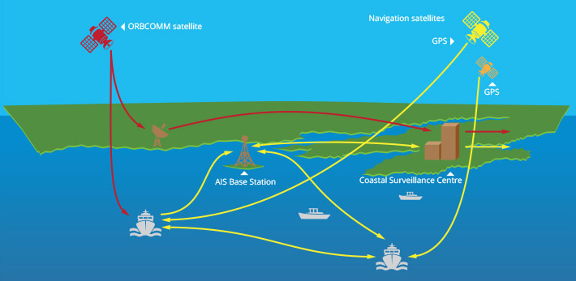
NEWLEO
The NEWLEO constellations are being created or promoted by companies such as OneWeb and Space X and LEOSAT and in the Cube SAT sector, companies such as Sky and Space Global. Last but not least there are MEO/GSO constellations with SES/O3B being the main player in this sector.
Table 7.4 lists these four sectors and the principle participants in each sector, the number of satellites either planned or in orbit, the spectrum allocation, pass band, satellite size/weight, typical data rate and functionality. A moderate health warning, this is a fast changing industry so this this table represents a snap shot in time rather than a long term record of constellation availability and gives examples rather than a full list of the companies involved.
Table 7.4 Four satellite sectors and examples of companies active in those sectors 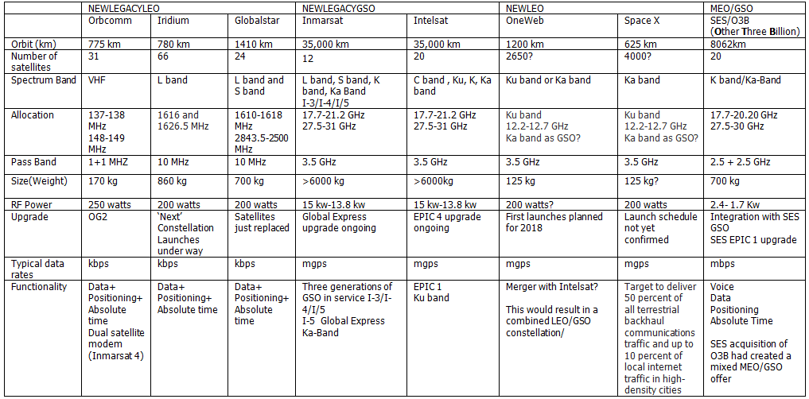
Table 7.5 should be interpreted with similar caution but provides a summary taken from FCC filings extant in 2016 and 2017 for new LEO constellations including their spectrum requirements, satellite count, orbit altitude and weight.
The total satellite count in space today is somewhere around about 4000 satellites and the table lists proposals to increase this twice over. This implies a rigorous regime of space debris management, a topic that we address at the end of this chapter.
Table 7.5 NEWLEO constellation proposals taken from 2016/2017 FCC Filings
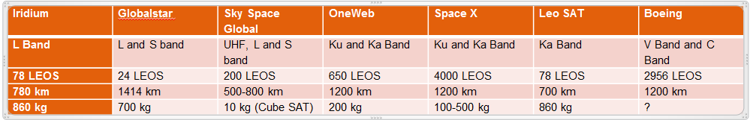

7.2 NEWLEGACYLEO COMPETITION

7.2.1 Iridium
Note that these NEWLEOS have to compete with existing LEOS that have twenty years of space experience and established and profitable and well established presence in a broad cross section of vertical markets and customer sectors.
We have already referenced the ongoing NEXT upgrade of the Iridium constellation (30 satellites launched in the first ten months of 2017 via three Space X rockets) and highlighted that the new generation constellation does more than just provide voice and data services and now includes for example positioning and location exploiting the strong Doppler signature of the constellation (and higher flux density than equivalent GNSS MEO constellations).
20 years of playing in space also produces an established and stable vendor supply chain. Figure 7.2 shows the companies involved in the NEXT constellation upgrade. Note that this highlights a substantive difference between the satellite industry and mobile broadband terrestrial mobile operator community. Mobile operators essentially have three vendors (Huawei, Ericsson and Nokia) that provide them with most of the plumbing needed to deliver 4G and 5 G services. Some but not all operators also have extensive in house R and D and engineering and implementation support teams though this is becoming less common. Satellite operators generally have a much more diverse supply chain and are more reliant on outsourcing. SES for example has a grand total of 69 employees with a turnover per employee of $33 million dollars.
This may of course change and indeed is probably already changing and it might be expected that the two supply chains might become more similar over time. In particular satellite operators with ambitions to deliver mass market services at consumer price points will need a supply chain that is geared to the scale economics that will be needed. We return to this topic in Chapter 8 (manufacturing innovation).
Figure 7.3 The Iridium NEXT supply chain – with thanks to Iridium

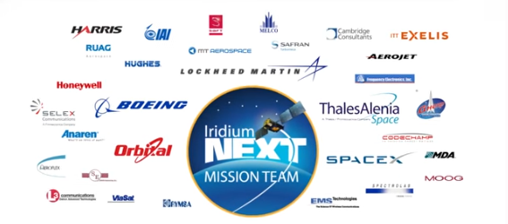
The Iridium NEXT constellation reuses the same orbit as the previous constellation and has the same L band uplink and downlink spectrum (see chapter 2)

Figure 7.4 Iridium Next Orbit Topology
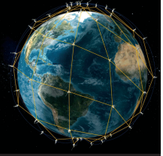
7.2.2 Globalstar
Originally formed in 1991 as a joint venture between Loral Systems and QUALCOMM, Globalstar has had technical and commercial challenges including RF hardware issues on some satellites and a period in Chapter 11 but has now completed an upgrade of the original constellation with 24 new satellites in three orbital planes. Globalstar shares the same L band spectrum as Iridium but has a smaller satellite count (24 rather than 66 operational satellites) which means lower capacity and fewer satellites visible at any time (two satellites visible at any one time in temperate zones).
Figure 7.5 New Globalstar Constellation
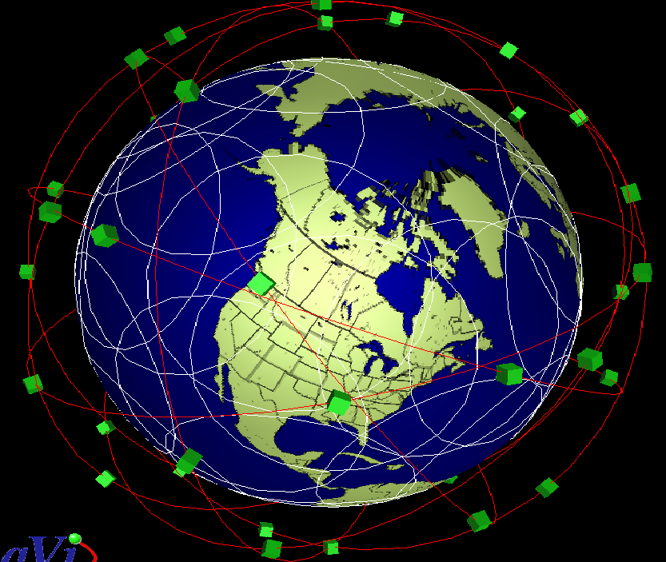
The satellite is bent pipe architecture and does not inter satellite switch which means more earth stations are needed. This adds opex and capex cost to the constellation but also introduces additional challenges managing potential interference between the uplink an downlink feeder links and other spectrally and geographically proximate earth and space based radio systems. (See Chapter 2 for more detail on this). Globalstar claim that bent pipe rather than regenerative architecture (where the uplink is demodulated and then modulated and coded again for the downlink) produces a lower latency though in practice this is dependent on the link budget.
Figure 7.6 Globalstar Ground Stations
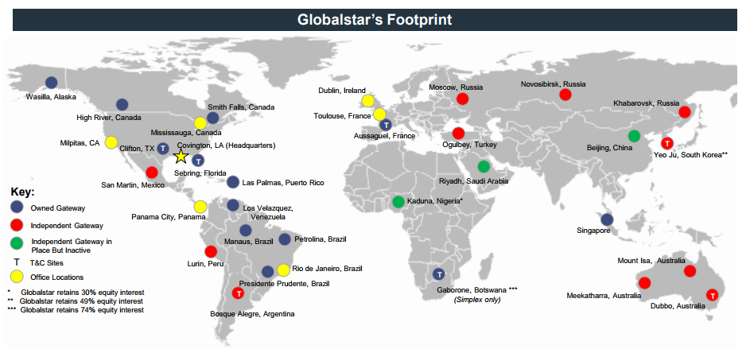
The bent pipe topology is shown in Figure 7.6 and shows the L band, S band and C band transceiver bands. The top of the lower C band allocation (5091-5250MHz) is immediately adjacent to the 5 GHZ Wi-Fi band from 5250 MHz to 5925 MHz including 8.2.11p (for automotive connectivity) at the top end of the band (5825-5925 MHz).
Figure 7.7 Globalstar Bent Pipe Topology
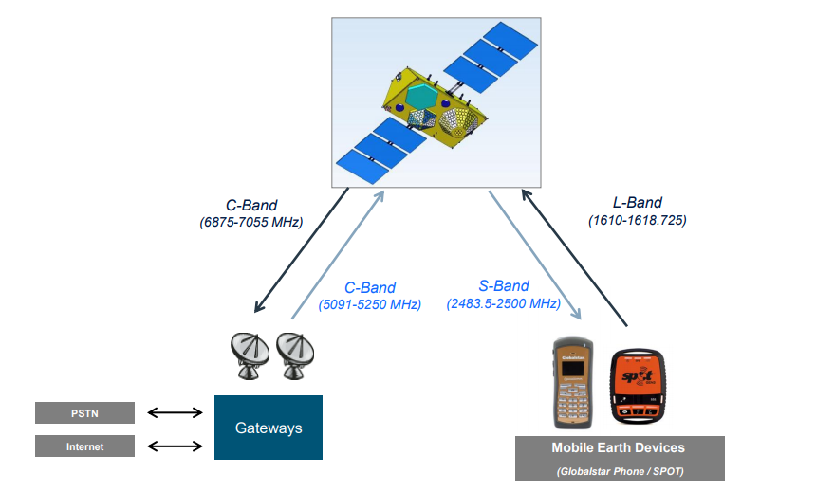
The new satellites have a life expectation of 15 years (twice the life of the previous generation) and support a data speed of 256 kbps (up from 9.6 kbps from the first generation constellation). The first constellation had a build out cost of $5 billion, the second constellation twenty years on cost $1 billion.
In addition to the L band user links, Globalstar has 11.5 MHz of S band spectrum allocated under FCC Part 25 rules providing full interference protection from adjacent services
The band is immediately above the intensively occupied 2.4 GHz Wi-Fi band.
Figure 7.8 Globalstar S Band Spectrum showing adjacency to intensively used 2.4 GHz Wi-Fi band
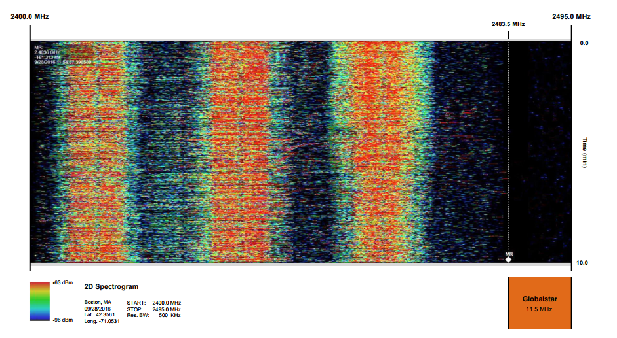
Figure 7.9 shows the adjacency and overlap of the Globalstar C band allocation with 5 GHz Wi-Fi.
Figure 7.9 Globalstar C Band adjacency and overlap with 5 GHz Wi-Fi
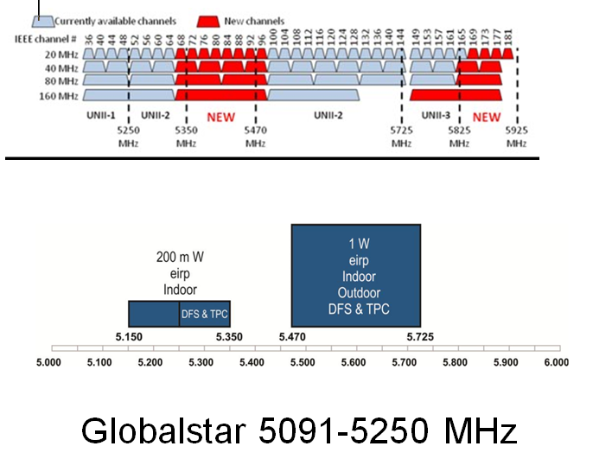
The band is immediately below FDD Band 7 and TDD Band 41. The proposed terrestrial physical layer is TD-LTE.
This is promoted as a global band but in practice many countries have deployed FDD Band 7 with TDD spectrum in the duplex spacing between the upper and lower pass band.
Table 7.4 Band 7 and Band 41
Globalstar S Band | Band 7
 | Mob TX FDD | Mob TX/RX TDD | Mob RX FDD
2483.5-2500 MHz | 2500-2570 MHz (70 MHz) | 2570-2620 (50 MHz) | 2620-2690 MHz (70 MHz)
 | Band 41
 | 2496 | 190 MHz including guard band | 2690
So while this might seem like a golden opportunity to roll out a global hybrid LTE and satellite phone network it may in practice be frustrated by regional and country specific implementations of LTE which are not compatible with the Globalstar TD-LTE ground component.
Note also that to date this is an FCC US rather than global spectrum assignment so Globalstar have to address regulatory approval in rest of the world markets or gain ITU acceptance of the sub band as a global LTE band.
Similarly while this might also seem like a golden opportunity to integrate the network with 2.4 GHz and 5 GHz Wi-Fi there could be potential out of band interference issues with 2.4 GHz Wi-Fi and in band interference issues with 5 GHz Wi-Fi which could frustrate commercial exploitation.
7.2.3 Device availability for hybrid cellular/satellite constellations
With QUALCOMM’s long term links with Globalstar it might be expected that a large range of market competitive devices could be made available.
Figure 7.10 shows devices listed at time of writing including a mobile phone with satellite functionality, a SAT-Fi mode providing a Wi-Fi hot spot coupled to the satellite and TDD LTE physical layer and a range of trekking, leisure and IOT devices.
Figure 7.10 Globalstar user and IOT devices
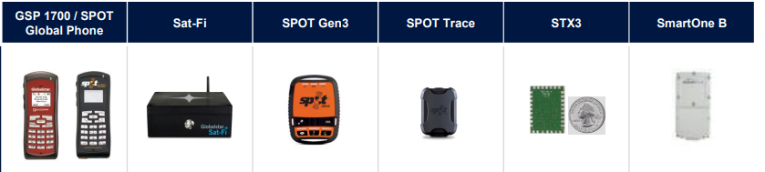
But what is really needed would be for satellite connectivity to be added to smart phones as standard. This is unlikely to happen due to the lack of global market scale (the Band 7/Band 41 issue). It would be theoretically possible to increase the pass band to include the 11.5 MHz of Globalstar spectrum but the wider pass band would decrease the sensitivity and selectivity of the Band 7 and or Band 41 LTE RF switch path and add to the cost of the phone. This is unlikely to be acceptable to the major handset vendors or their operator customers
Inmarsat are likely to have similar issues with their European Aviation Network (EAN) though in their case their spectrum is adjacent to Band 1. As a reminder, here is the EAN band plan (last seen in Chapter 2)
Table 7.5 Another S band adjacency challenge/opportunity
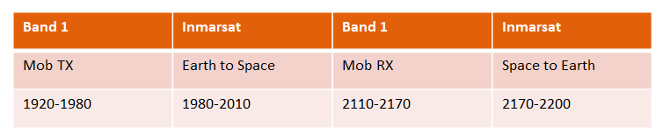
7.3 NEWLEOS
Angular power separation
As already discussed the NEWLEOS are significantly different to the legacy LEOS both in terms of their satellite count and available bandwidth and orbit RF power but also in the way that they propose to share spectrum with the MEO and GSO satellites flying above them.
This brings us back to the knotty topic of progressive pitch and angular power separation.
In Chapter 2 we referenced Skybridge and Teledesic as the two entities that first introduced the concept of progressive pitch angular power separation as a mechanism for co sharing spectrum with MEO and GSO constellations. Bear in mind that this was twenty years ago but the basic principle remains the same though with substantial fine tuning now possible. Put simply a low earth orbit satellite at high latitude can look directly downwards at a LEO satellite dish or flat panel array antenna on earth pointing upwards. A dish at the same location looking at a GSO satellite will be focused at a low elevation angle pointing close to the horizon which should mean that it receives no signal energy or not much signal energy from the overhead LEO.
At the equator both the GSO and LEO (and MEO) satellites will all be looking directly downwards and the satellite dishes will be pointing directly upwards. If the same operator in the same spectrum manages all three constellations then you could have a scenario in which equatorial users could uplink and downlink simultaneously from all three constellations which would produce some interesting and useful amounts of Ku, K and Ka-bandwidth combined with interesting and useful amounts of downlink power and uplink sensitivity.
However if different operators manage different constellations there is an inherent interference issue. Established GSO operators for example who are currently investing in high throughput GSO satellites in Ku, K and Ka-band are less than enthusiastic about a NEWLEO operator pouring unwanted signal energy into their GSO terrestrial receive pass band.
The solution promoted by the NEWLEOS is to switch off transmissions as the satellites pass over the equator. As the NEWLEO satellite moves away from the equator it can restart transmission but needs to ensure that the elevation angle is sufficiently acute to avoid interference with GSO earth based receivers. This is accomplished by changing the pitch of the satellite progressively, hence the description ‘progressive pitch’ but combined with power control and handover to other satellites operating at a lower elevation angle.
The detail of how this is done is dependent on orbit altitude, orbit speed/duration (a consequence of altitude), orbit path, RF Power and sensitivity and regulatory constraints (agreed protection ratios)
For the NEWLEOS, the best link is always going to be directly overhead so any lower angle will require a longer path through the atmosphere and a higher chance of blocking from buildings and foliage. Latency will also increase and the link budget will be lower and more variable. Because the signal needs to pass through more atmosphere it is more likely to be affected by rain fade. Agreeing coexistence conditions and ratifying these agreements through legal and regulatory channels is therefore critical to the economic viability of these new constellations.
Figure 7.11 is a graphic showing the principle of angular power separation applied to the coexistence of the O3b MEO network and SES GSO. Given that SES now fully owns O3b it might be thought that this would be relatively non-contentious but of course any and all other GSO operators sharing this spectrum also need to be reassured that protection ratios can be managed and any in band or out of band interference limited to a level where no economic cost is projected on other operators or alternatively, if there is an economic cost, that it is fully compensated. There are also adjacency issues with military users that needs to be accommodated (See Chapter 2).

Figure 7.11 Angular separation of the 03b MEO constellation from the SES GSO constellation
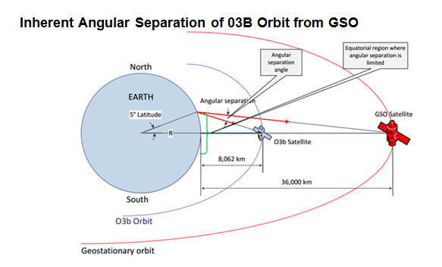
Figure 7.12 shows the potential complexity of this calculation in terms of the satellite count of both constellations.
Figure 7.12 SES and 03b fleet map
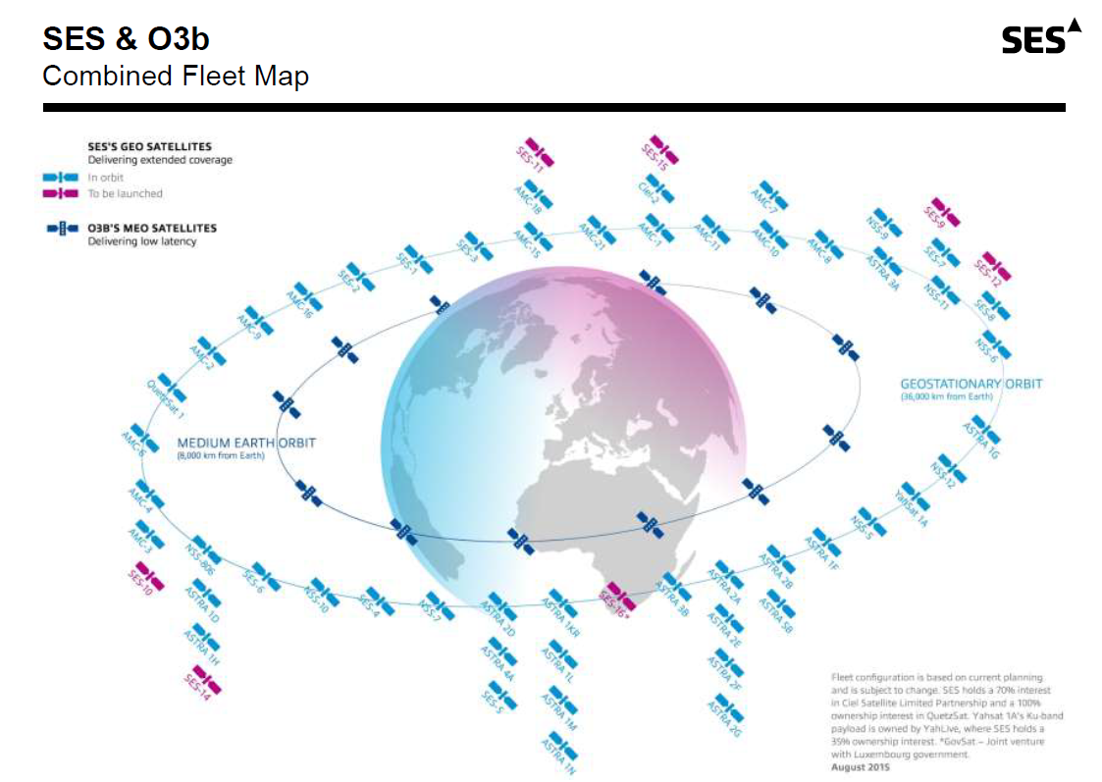

Figure 7.13 shows the number of ground stations and gateways and the coverage map.
Figure 7.13 SES/O3b ground stations, gateways and coverage map
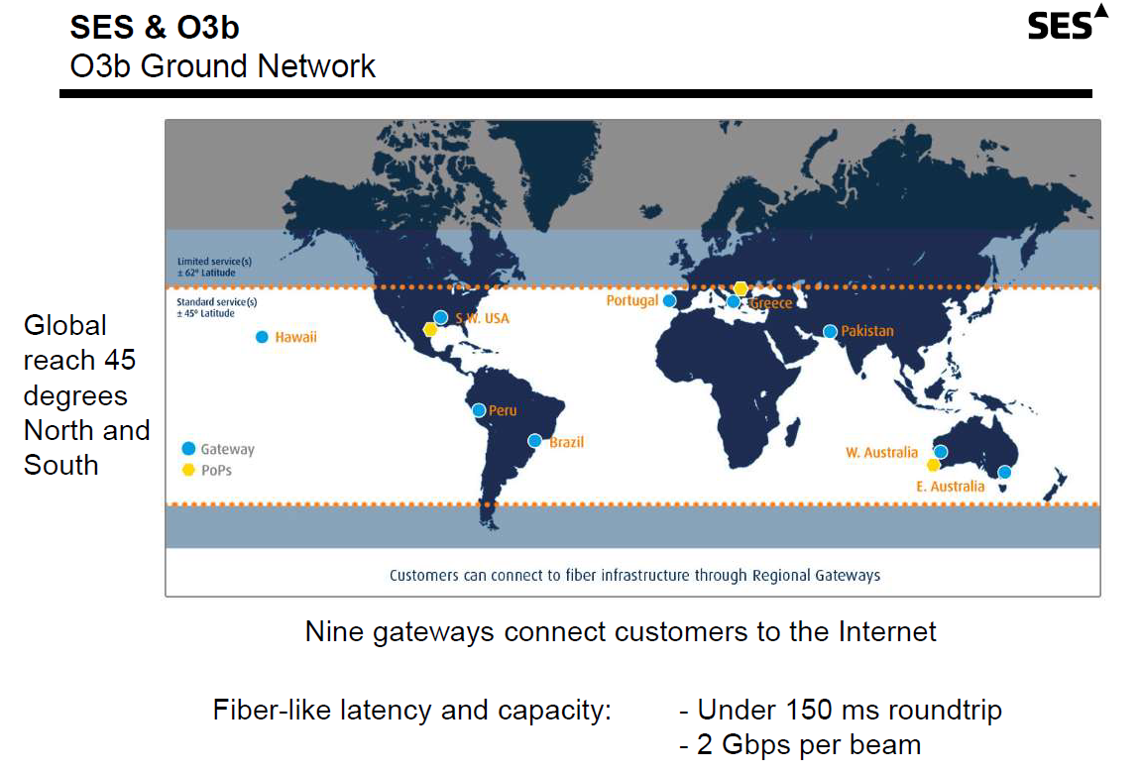
7.4 OneWeb Coexistence
The issues around MEO/GSO coexistence are a mere warm up act for the debate that is presently swirling around NEWLEO interference calculations with OneWeb as the poster child of the sector.
First a reminder of OneWeb’s network topology. More detail is available from the FCC web site.

Earth Stations
OneWeb proposes to have 50 gateway earth stations with at least four deployed in the USA including Hawaii and Alaska. The gateway earth stations will also transmit and receive control channels for satellite payload control and gateway link power control. A subset of gateway sites in high latitude regions of the world will provide telemetry tracking and command (TT and C). There will be at least two separate satellite control centres, probably in Virginia, USA and the UK with network operations controlled from the UK and Melbourne, Florida. Payload control transmissions to and from the US gateway earth stations will take place in the band edges just below 19.3 GHz (downlink) and just above 27.5 GHz (uplink).

Satellite Beams
Each OneWeb satellite will have 16 nominally identical user beams, operating in Ku band, each consisting of a non-steerable highly elliptical spot beam. There are also two identical steerable gateway beam antennas operating in Ka band. Each of these antennas creates an independently steerable circular spot beam. The second beam tracks the next gateway earth station for handover procedures.
While the Ku band user beams cannot be steered, the Ku-band footprint can be moved up and down in latitude. OneWeb call this Progressive Pitch. The attitude control system of each satellite allows the pointing of the satellite to be adjusted so the beam pattern can be moved in the pitch direction (north to south). The power output from each beam can also be controlled and adjusted to meet EIRP and flux density country specific regulatory requirements.
The movement of the satellites in their orbits means that a user will be progressively handed over from beam to beam within a OneWeb satellite and then handed off to the beams on the next satellite in the same orbital plane or adjacent plane.
Each user beam supports services to multiple user terminals. In the forward direction (gateway to user) there is a TDM transmission scheme within a single 250 MHz channel. Each user terminal in the beam receives and demodulates the whole carrier and extracts only the data destined for it which is determined by the data headers (and potentially also the position in the TDM transmission?). In the return direction (user to gateway) there is a Single Carrier TDMA/FDMA transmission scheme modulated on to a relatively narrow band carrier (1.25 MHz to 20 MHz wide).
On the basis of 720 satellites, every point on the earth’s surface will see at all times a OneWeb satellite at an elevation of no less than 55 degrees with increasing minimum elevation with latitude.
Figure 7.14: OneWeb Coverage showing simplified circular footprints for each satellite

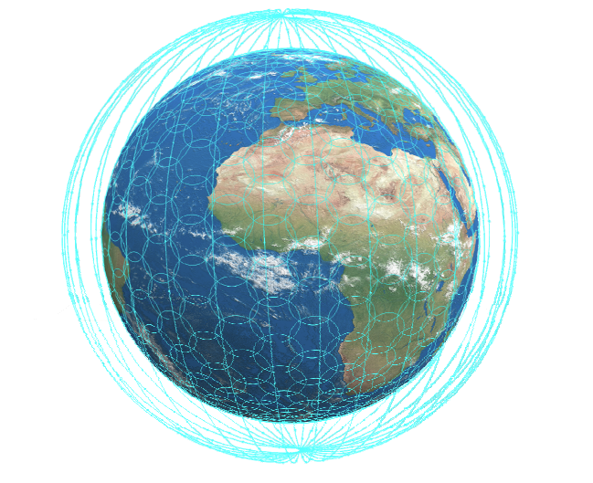

Figure 7.15 shows angular power separation applied to the coexistence of the OneWeb NEWLEO with GSO (with a similar approach for NEWLEO to MEO coexistence)
Figure 7.15 OneWeb Angular Power Separation

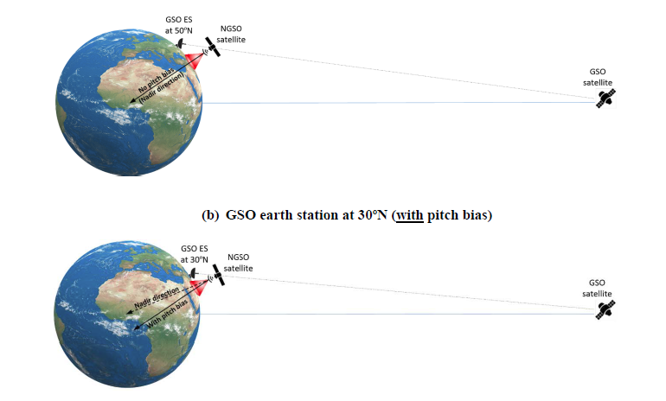
OneWeb Interference Management
The FCC power flux density (PFD) requirements and associated calculated allowable EIRP are documented in detail in the FCC and ITU filings. The ITU PFD limits applicable to NGSO systems in the 10.7 to 11.7 GHz band can be found in Table 21.5 of the ITU radio regulations and are effectively the same as the FCC PFD limits. OneWeb document their methodology for calculating maximum EIRP density for all angles of arrival and departure across the Ku, K and Ka-band pass bands taking into account the spreading loss from the satellite to the surface of the earth (i.e. the variation in signal strength over the elliptical area illuminated). They review their methodology for demonstrating compliance with the FCC and ITU EIRP and PFD limits established to minimise interference to GSO systems and their methods for calculating interference from GSO satellites into the OneWeb network including other mechanisms such as power control which are used to deliver constant flux density at different elevation angles. Note that lower elevation angles will absorb more RF power and will therefore reduce the capacity of the constellation which in turn reduces the technical and commercial efficiency of the constellation. These technical details and the interference and coexistence assumptions behind these technical details determine the economic viability of the business model.
‘Progressive pitch’ also described by OneWeb as ‘pitch bias’ takes place gradually as the satellite passes through mid-latitudes to lower latitudes. As the satellites pass over the equator they temporally turn off RF power and then adjust their pitch to the opposite direction. Pitch adjustment is managed by reaction wheels.
OneWeb document their methodology for demonstrating that they comply with the required protection ratios for Ka band GSO networks. Note that the gateway antennas on the OneWeb satellites are fractional beam width (less than half a degree half power bandwidth) in order to minimize the number of required gateway sites. This yields a gain of typically 55 dBi on the transmit path and 51.5 dBi on the receive path.
OneWeb are required to demonstrate that the siting of their gateway sites and the constraints on the number of possible positions of OneWeb satellites with which each gateway site can communicate will reduce OneWeb gateway to GSO Ka-band interference to an acceptable level. OneWeb are proposing to operate their user terminal earth stations on a non-interference non-protected basis which means that the receiving earth stations will not seek interference protection from fixed services in the band.
There are also fixed service links in the 12.2 to 12.7 GHz band issued under old FCC allocations. These are now ‘grandfathered’ which means that no new allocations will be made but OneWeb are still required to demonstrate that the protection ratios for these services are met.

7.4 Coexistence with GSO Systems
The filing document addresses coexistence with MVDDS (Multi Channel Video and Data Distribution Service) with proposed sharing mechanisms based on data base sharing of each systems transmitters and receivers in the 12.2 to 12.7 GHz band (shades of sub 1 GHz White Space). Dish Networks deliver TV over these bands and are mounting a rigorous defence of MVDDS spectrum access rights in the USA.
Interference mitigation with respect to terrestrial networks in the 17.8 to 18.3 GHz band is also addressed. The band is used by OneWeb in the space to earth direction for a relatively small number of earth stations. Similar procedures apply with respect to terrestrial networks in the 27.5 to 28.35 GHz band. Terrestrial LMDS (Local Multipoint Distribution Systems) have access to this spectrum on a primary basis and are licensed by the FCC by geographic area. The position of OneWeb gateways will therefore need to be coordinated with any local LMDS operators. OneWeb as a secondary user in this band has to accept incoming interference from the primary user.
OneWeb will also need to coordinate with NASA to guarantee protection of TDRSS (Tracking and Data Relay Satellite Systems) in the 14.0 to 14.2 GHz band and with space observatories operating radio astronomy services in the 10.6 to 10.7 GHz band and with US government satellite networks, both GSO and NGSO in Ka band.
Note that all these coexistence calculations need to account for the additive power received at victim receivers from all visible OneWeb satellites and earth stations with the EIRP mask characterised for worst case modulation and traffic patterns. This includes worst case conditions defined as the maximum number of non-geostationary satellites transmitting and receiving simultaneously with overlapping frequencies from the associated earth stations within a given cell defined on a per square kilometre basis. The calculations need to include the required minimum GSO avoidance angle.
Figure 7.16 shows how this is calculated
Figure 7.16 Definition of the Avoidance Angle
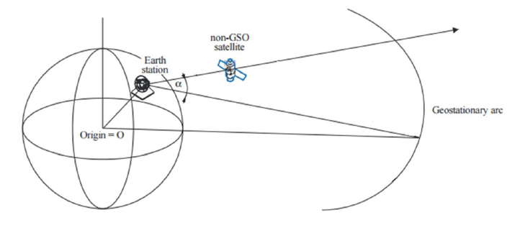
Interference from a OneWeb satellite to a GSO also needs to take into account path length as is shown in Figure 7.17
Figure 7.17 Difference in Path Length from OneWeb Orbit to GSO

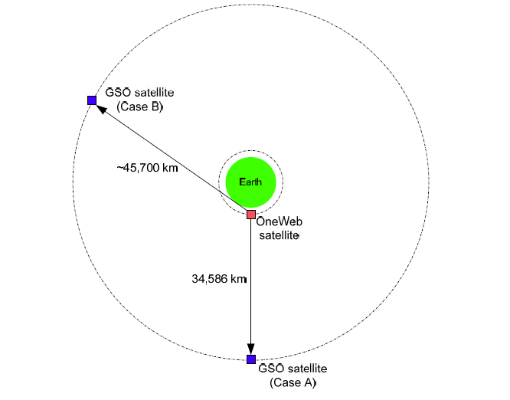
As can be seen, demonstrating compliance with the coexistence conditions (protection ratios) for existing incumbent users in OneWeb’s Ku and K and Ka-band spectrum is complex and subject to legal challenge. And this is just one market (the US) and one filing (the FCC) and one constellation and will need to be repeated for each and every other market in the rest of the world.
In particular characterising the mitigation achieved by angular power protection is open to technical interpretation and likely will be used by incumbents to defend their spectral access rights and market position. Note that the NEWLEO constellations have higher satellite count (hundreds or thousands of satellites) than the O3b MEO network and many more satellites than any of the GSO operator’s (Intelsat has 40 orbital slots).
Figure 7.18 shows the Space X footprint and typical elevation angles. Changing the pitch of the satellite will of course make the elevation angles asymmetric across the diameter of the cell.
Figure 7.18 Space X elevation angles without pitch control

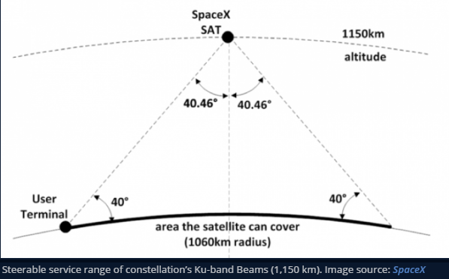

Dish Networks also have a patent pending on progressive pitch as probably do other entities with NEWLEO constellation ambitions.
7.4 Angular Power separation and Active Electronically Steerable Antenna Arrays
Casting your memory back to Chapter 6 you will remember we covered Active Electronically Steerable Arrays (AES arrays). AES arrays are particularly interesting when considered as an integral part of a NEWLEO with progressive pitch for several reasons.
AES arrays can do horizon to horizon scanning to evaluate the angle of arrival of wanted and unwanted signal energy and use this information to null out unwanted energy and provide gain to wanted energy received from a specific elevation angle and area of sky. If this data can be captured and consolidated, it gives a near real time picture of both the serving network and other networks either co sharing the band or in adjacent spectrum.
On the transmit side, knowledge of angle of arrival allows an optimum angle of departure to be calculated minimising uplink power consumption and minimising interference into space based systems. AES antennas can perform these functions in any band from VHF to Q band though in practice size constraints make higher bands/shorter wavelengths a preferred option
AES antennas are however not going to be universal due to cost. Few TV subscribers would want to replace their low cost Ku-band satellite dish with a planar array costing ten times as much as the dish. Active arrays are also sensitive to large temperature gradients, for example on the roof of a car or truck and therefore may not be an optimum choice for some applications.
This means that the NEWLEO constellations need to show that they will not cause interference into dish antennas or passive flat antennas.
7.5 Interference calculations and other arguments
The problem with interference calculations is agreeing on how the calculations of interference should be done particularly given that with high count LEO constellations in particular there are no broadly based empirical measurements that can be used to validate and fine tune propagation models, channel models and statistically based interference modelling.
This is not a new issue for the industry. The TV industry spent ten years questioning the assumptions and modelling methods used to calculate LTE to TV interference in the 800 MHz (first digital dividend), 700 MHz (second digital dividend) and 600 MHz band (third digital dividend).
The default would have been for the mobile broadband operator community to accept a set of worst case interference conditions but this would have resulted in protection ratios that would have made much of the spectrum being auctioned either unusable or seriously compromised. The discussions also had to cover second order effects such as the impact of pulse trains from the LTE signal compromising the low cost automatic gain control of TV receivers. In the end, common sense prevailed, an amount of money changed hands and everybody (more or less) lived happily ever after.
It could be expected that the same accommodation could be found between GSO satellite operators and the NEWLEO operators but in practice the known unknowns and the unknown unknowns implicit in modelling interference theoretically without recourse to empirical data introduces an unsettling degree of uncertainty and room for debate and litigation.
This is illustrated by a case study kindly provided by Asia Broadcast Satellite based on a presentation given at a Cable and Satellite Broadcasting Event in 2015. The case study looks specifically at the issue of OneWeb to TV interference in Ku-band.
The case study opens with a summary of OneWeb’s orbital characteristics
Figure 7.19 OneWeb Orbital Characteristics
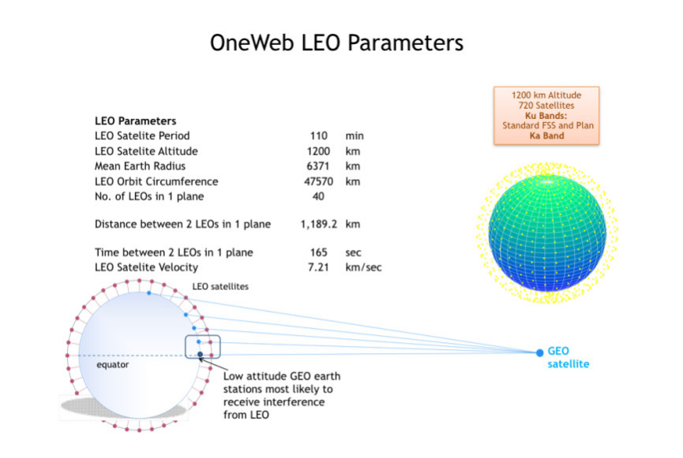
Article 22 of the ITU Radio Regulations is referenced in terms of the definition of equivalent power flux density allowable from the NGSO (NEWLEO) constellation taking into account that the flux density (unwanted signal energy) could be the composite of all or some of NEW LEO satellites visible from horizon to horizon.
Figure 7.20 ITU EPFD limits assuming a 60 cm dish antenna for TV reception
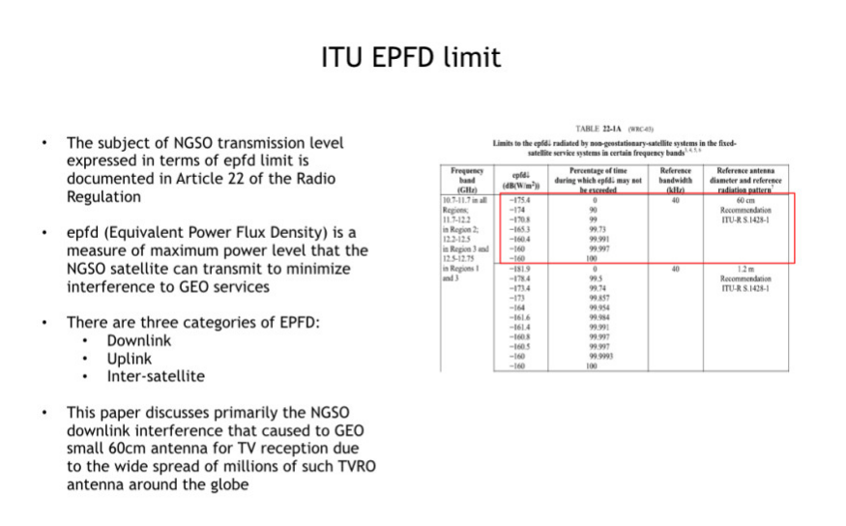
The assertion is made that compliance with this limit would not guarantee that satellite TV reception would not be compromised.
Figure 7.21 Interference into a 60 centimetre TV dish with Article 22 EPFD level
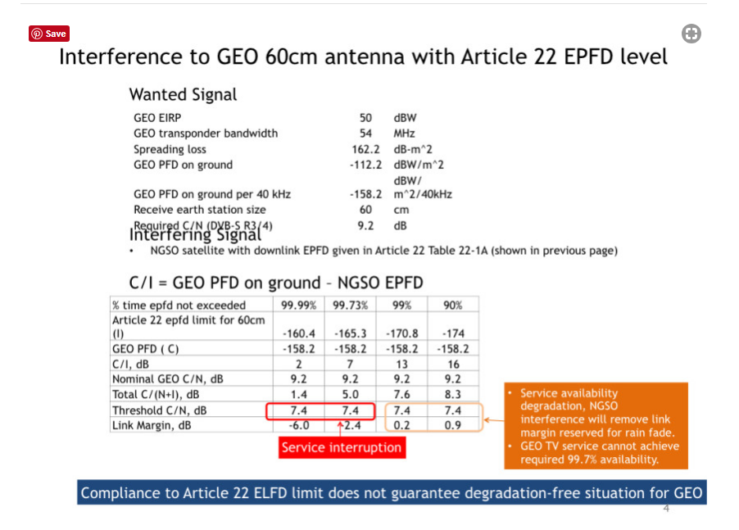
The following figure calculates the equivalent allowable Effective Isotropic radiated power from the OneWeb constellation assuming the Article 22 EPFD limits
Figure 7.22 Equivalent EIRP levels for the Article 22 EPFD limits
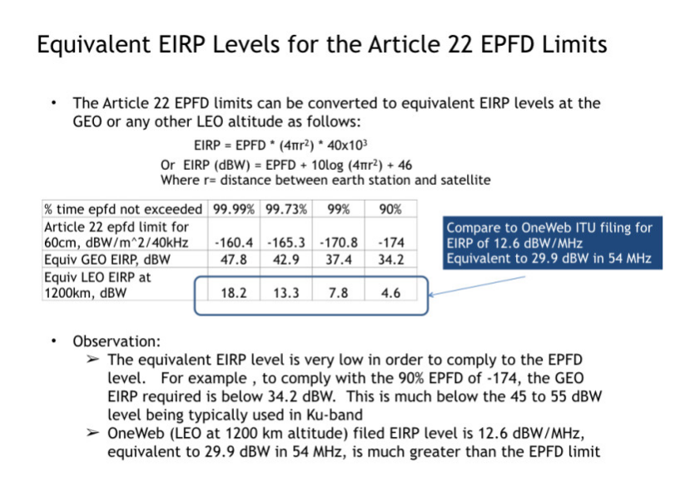
The study then looks at the cone of visibility from the victim antenna and the pass rates of the satellites to calculate outage times.
Figure 7.23 Estimation of Interference Duration for a GEO TV receive 60 centimetre antenna at low latitude showing the potential limitations of progressive pitch
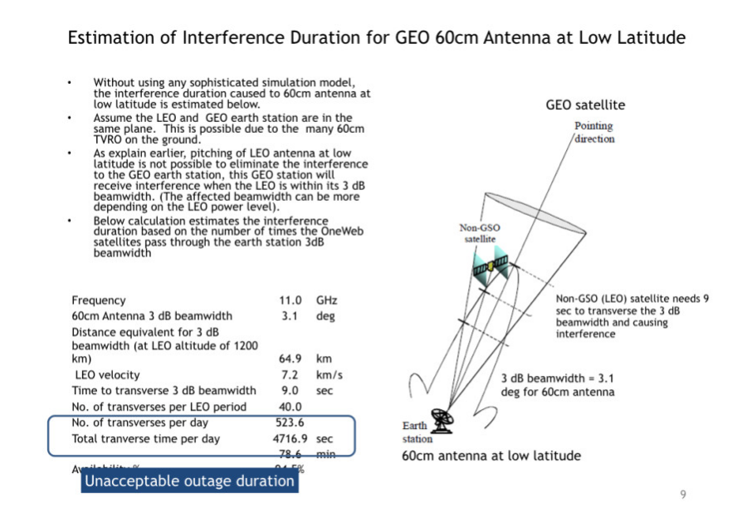
To complicate matters the calculation then has to be done for multiple satellites.
Figure 7.24 Composite interference from 4 satellites
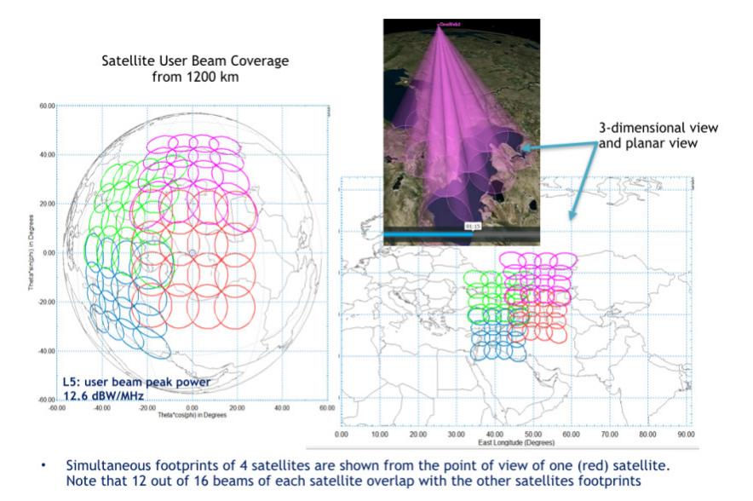
On the basis of the above assumptions, an interference model is proposed
Figure 7.25 Interference Model
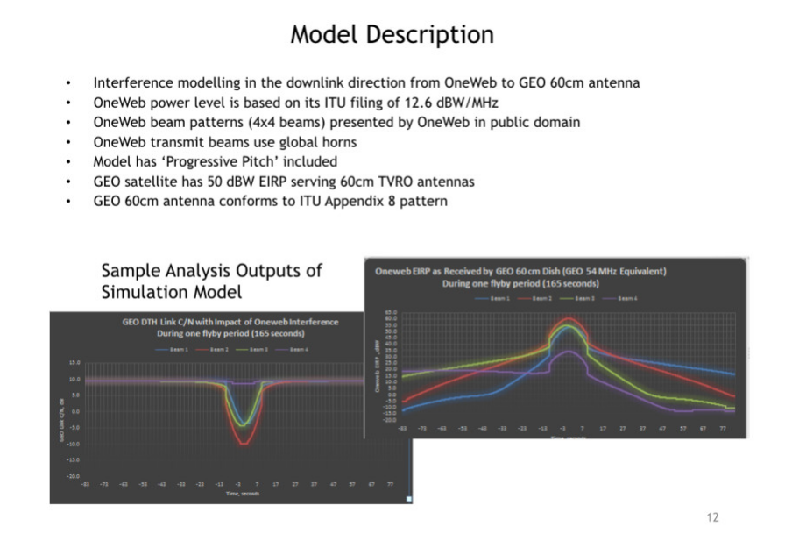
The outputs of the model show that progressive pitch does not provide sufficient protection at low elevation/low attitude.
Figure 7.26 Model Analysis Result
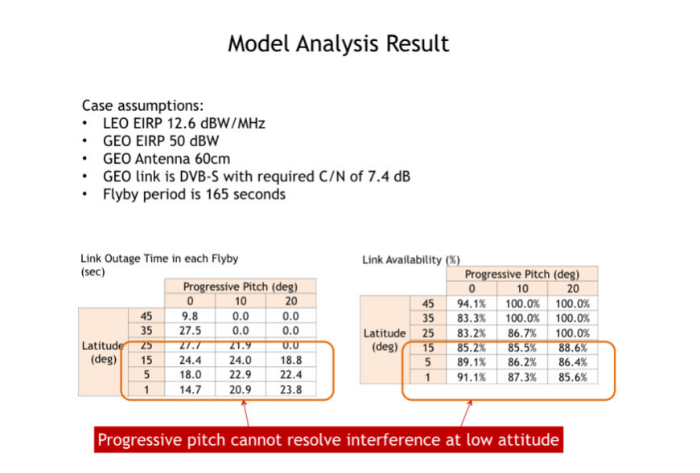
Self-evidently OneWeb and or any other NEWLEO entity would use a different set of assumptions and end up with a completely different result but the point we are trying to make is that this is a multi-dimensional modelling requirement which is in reality far more complex than the simple case study of NEWLEO to TV interference given that it needs to potentially comprehend multiple LEO constellations all with different orbits and numbers of satellites and RF power and interference mitigation techniques interacting with GSO and MEO satellites that are either in band or spectrally adjacent delivering angular power across an infinite rage of inclination angles in a wide range of propagation conditions mapped against an infinite number of line of sight and non-line of sight paths with ground reflection and scatter and surface absorption components that need to be factored in to the model
If you have read that paragraph aloud take a deep breath.
Then the calculation has to be repeated for K band and Ka-band feeder links and then repeated again to assess interference levels with in band and adjacent band terrestrial 5G.
7.4 The answer- Mixed constellations including 5G including existing examples
The only plausible answer to this modelling problem is to remove the incentive to argue and this can only be done if the same entity owns and manages a GSO constellation and MEO constellation and LEO constellation and preferably 5G terrestrial assets as well.
This would require seismic changes to existing competition policy and regulatory policy but would provide a uniquely powerful user experience and uniquely powerful platform for global IOT connectivity.
The concept of providing coverage from a mixed constellation is not new or untried. Communications with the Hubble Telescope (launched in 1993 into a Low earth Orbit at 600 km) and International Space Station (launched in 1998 into a low earth orbit at 400 km) go up to a GSO (The GSO Near Earth Network) before coming back to earth. This is known as the Near Earth Network. A number of satellite providers are moving some way to this mixed constellation model including SES/03b and Inmarsat. The end result provides a combination of good east to west and north to south global coverage with a significant improvement in uplink and downlink power budget and capacity.
Figure 7.27 The Near Earth Network as an example of a mixed constellation
The Hubble Telescope
The Hubble Orbit
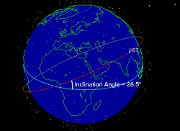
The International Space Station
The Near Earth Network is part of the NASA Tracking Data And Relay Service which was started in the early 1970’s
Figure 7.28 is an image of a TDRS satellite.
Figure 7.28 TDRS satellite
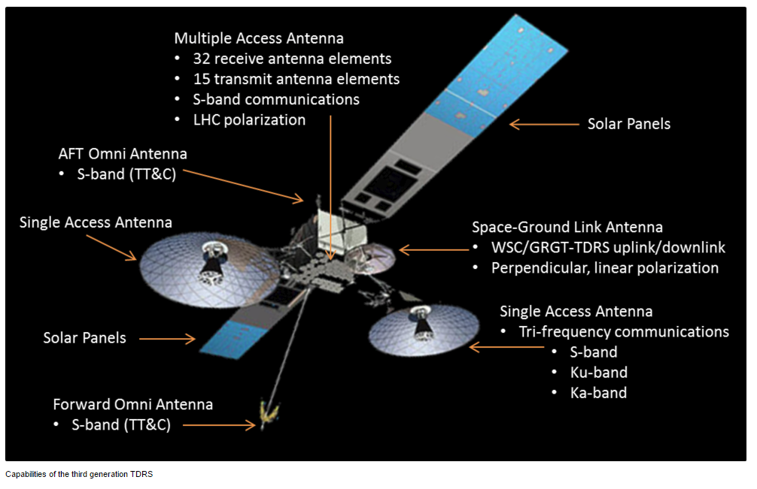
Incidentally, NEWLEOS such as OneWeb will need to coordinate with NASA to guarantee protection of TDRSS (Tracking and Data Relay Satellite Systems) in the 14.0 to 14.2 GHz band and with space observatories operating radio astronomy services in the 10.6 to 10.7 GHz band and with US government satellite networks, both GSO and NGSO in Ka-band. These agencies are not generally motivated by the prospect of having to manage new sources of interference and have nothing to gain from saying yes.
7.5 GSO HTS and VHTS Constellation Innovation
Meanwhile GSO constellation innovation marches on. GSO constellation innovation is driven by multiple factors. As launch technology improves, larger heavier satellites can be lifted into GSO orbit which means that the amount of available RF power increases. The satellites have ever more complex spot beam antennas that can focus that RF power on discrete geographic areas and or to respond to changes in demand. Those spot beams are communicating with earth based ground stations which can be fixed or mobile with antennas that can actively discriminate wanted energy from unwanted energy. This increases thoughput and improves the power efficiency and spectral efficiency and cost efficiency of the overall system.
Over the past ten years these technical advances have enabled the introduction of the new generation of high throughput (HTS) satellites (>1gbps of throughput) and over the next ten years can be expected to enable the introduction of the next generation of very high throughput satellites (VHTS) in V and W band (>10 gbps of thoughput). Fibre, cable and copper and terrestrial cellular throughput is also increasing in parallel. In this next section we set out to see how these advances might change how GSO constellations interact technically and commercially with the rest of the telecommunications industry.
First we need to separate out the different commercial entities participating in the GSO market, specifically differentiating global satellite providers from regional providers and the Sovereign SATS
7.5.1 The Global GSO’s
The global GSOs are entities that own and operate or have access to anything between 4 and 40 satellites in geostationary orbit.
Figure 7.29 shows the global coverage available from the four Inmarsat Global Xpress high throughput satellites.
Figure 7.29 Inmarsat Global Xpress Coverage Map
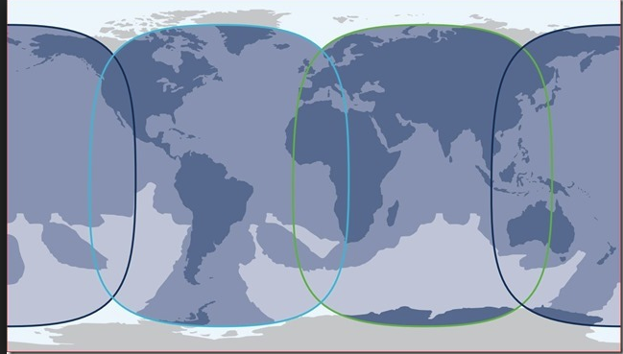

Note that while Inmarsat was originally focussed on maritime coverage (hence the name) it now vigorously addresses terrestrial markets (and has provided terrestrial services for over thirty years).Similarly companies such as Intelsat who have traditionally focused on terrestrial markets are also addressing maritime markets.
The pictures from the Moon landing in 1969 were sent round the world via Intelsat GSO satellites. Intelsat was privatised in 2001 two years after Inmarsat. This coincided with the dot com bust, the telecoms meltdown (Nortel going bankrupt) and the global fibre glut. In 2006 Intelsat acquired Pan Am SAT becoming the world’s largest fixed service satellite service provider. It has constellation assets in C band, Ku and Ka band.
Intelsat provide an alternative to Inmarsat from a Ku-band constellation and launched the first of a new generation of six satellites in January 2016 via Europe’s Ariane 5 heavy lift rocket. The new satellites weigh over 6,500 kilograms and are positioned to cover the Caribbean and North Atlantic cruise routes (and land mass as well). The satellites are manufactured by Boeing.
Figure 7.30 Intelsat KU Band HTS Coverage Footprint
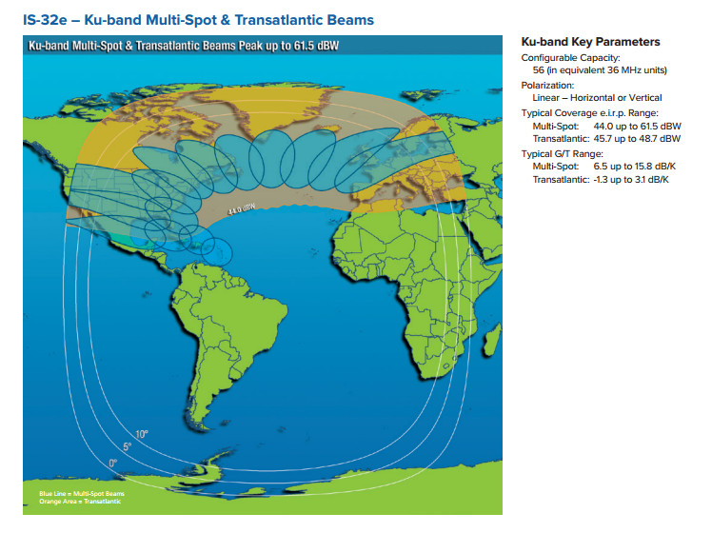
7.5.2 Other Global GSO’s
Other global GSO’s include Eutelsat and Viasat. Eutelsat also now known as Eutelsat Ka SAT was formed in 1977 to operate the first European satellites (launched in 1983). After the fall of the Berlin Wall, Eutelsat was extended to cover Eastern Europe. It was privatised in July 2001 and went through an IPO in 2005. TV still represents a substantive part of Eutelsat’s income, broadcasting to the Middle East, Turkey and Africa from the Hot Bird satellites. In January 2014, Eutelsat acquired SATMEX (Mexico) which effectively means the company provides providing coverage of Europe, Africa, the Middle East, Asia and the Americas. The EUTELSAT 7C electric satellite is scheduled to launch in the third quarter of 2018. The satellite will have 44 Ku-band transponders and will be co-sited at 7° East position for Turkey and Sub Saharan Africa doubling the number of transponders from 22 to 42 over Sub Saharan Africa. This means that Eutelsat will be offering capacity from more than 40 satellites. This represents a big share of the available geostationary orbit slots (even taking into account co-siting).
Viasat has expanded its footprint in three stages to deliver global coverage
The three images show the progressive expansion from its initial US coverage footprint.
Figure 7.31 Viasat Coverage maps
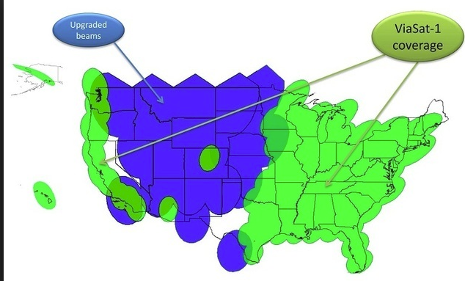
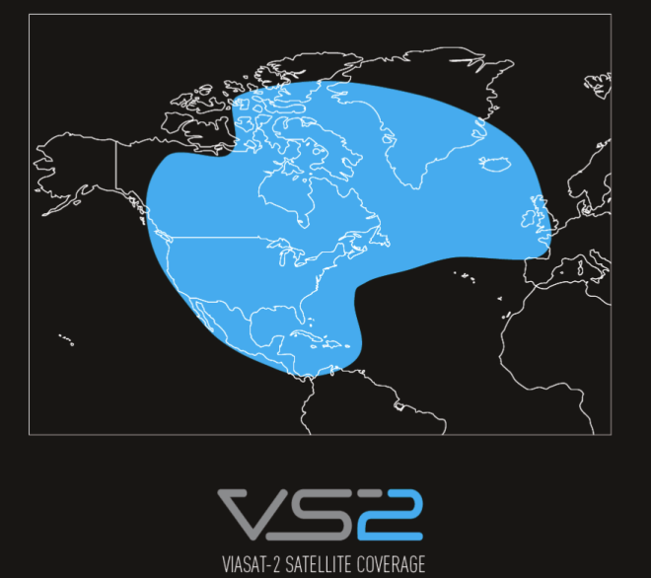
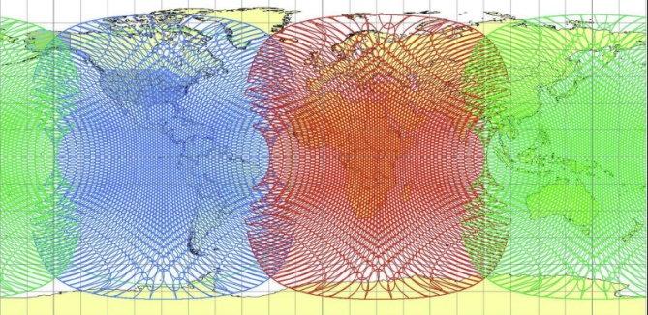

7.6 The Regional SATS
IP Star was the first of the regional HTS satellites (launched in 2005)
Figure 7.32 IP Star satellite 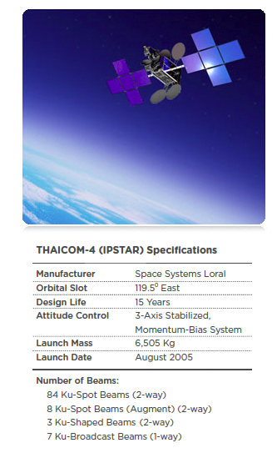
Figure 7.33 Coverage from 4 IP Star satellites
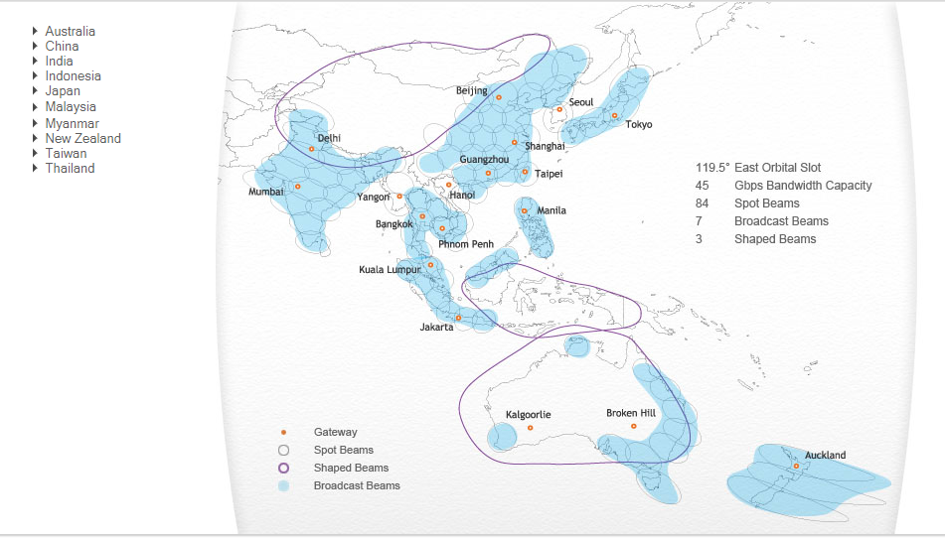
Other regional SATS include Arabsat, Hispasat and Hylas (Avanti).
7.7 The Sovereign SATS
These include companies such as Telesat and national network constellations in Australia (part of Australia’s National Broadband Network) and Singapore, Brazil, India, Indonesia, China, Iran and Israel.
7.8 VHTS Constellations
VHTS constellations are being proposed as the basis for specific new spectrum allocations at WRC 2019 at 32 GHz Band (31.8-33.4 GHz) and in Q and V band (37-52 GHz). This is described in WRC-19 agenda item 9.1.9.
SpaceX, OneWeb, Telesat, O3b Networks and Theia Holdings all have submissions with the FCC for V-band satellites in non-geosynchronous orbits to provide communications services in the United States and elsewhere.
The Boeing submission is to use 37.5 to 42.5 GHz range of V-band for downlinking from spacecraft to terminals on Earth, and 47.2 to 50.2 GHz and 50.4 to 52.4 GHz) for uplinking back to the satellites using 1,396 to 2,956 low-Earth orbit (LEO) satellites .
SpaceX proposes a “VLEO,” or V-band low-Earth orbit (LEO) constellation of 7,518 satellites to follow the operator’s initially proposed 4,425 satellites that would function in Ka- and Ku-band. Canada-based Telesat describes its V-band LEO constellation as one that “will follow closely the design of the Ka-band LEO Constellation,” using 117 satellites not counting spares as a second-generation overlay.
Theia asked the FCC to allow it to use V-band frequencies for gateways on the ground that would have originally only used Ka-band.
OneWeb wants to operate a “sub-constellation” of 720 LEO V-band satellites at 1,200 kilometres, and another constellation in Medium Earth Orbit (MEO) of 1,280 satellites expanding the OneWeb constellation by 2000 satellites. Traffic would be dynamically assigned between the LEO and MEO V-band constellations based on service requirements and the data traffic within coverage areas.
OneWeb’s application for MEO follows that of ViaSat’s in November for 24 MEO satellites to augment Viasat 3, the company’s trio of terabit-per-second-throughput satellites currently underway. Viasat bundled its request for use of V-band together with its application for MEO Ka-band. O3b wants market access to V-band for up to 24 additional satellites that would operate in a circular equatorial orbit as a constellation called O3bN.
7.9 Autonomous Cube SATS
We have already covered Cube SATs in our earier chapter on satellite innovation but is is worth briefly revisiting some of the more active particpants in the sector. Whereas GSO satelites tend to expand coverage by longitude, Cube SATS expand their coverage by latitude. Figure 7.34 shows the initial equatorial coverage from the proposed SAS Cube SAT constellation (200 satellites each weighing 10 kilogrammes).
Figure 7.34 Sky and Space Autonomous Satellite Constellation
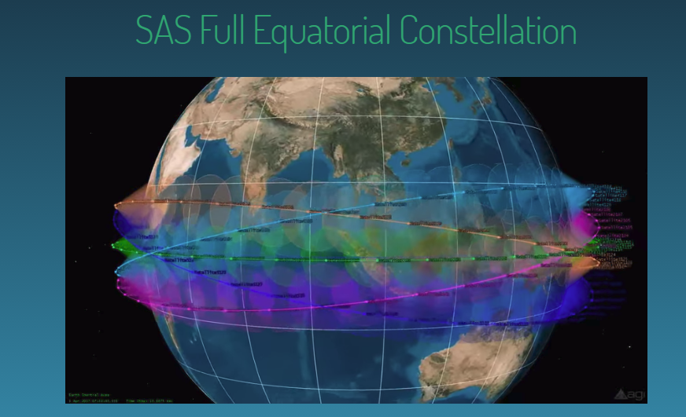
The interesting things about the SAS constellation is that the satellites have on board orbit control and autonomous network management which makes the space segment independent from terrestrial control. The constellation also proposes to use 4 way Intersatellite links (up, down and side to side).
7.10 Space Sensing Constellations
Our focus in this book is on communication satellites but there is a parallel increase in the use of satellites for imaging and sensing. The Planet Labs Rapid Eye constellation is a present example. 5 one cubic metre satellites each weighing 150 kilogrammes in a 630 kilometre sun synchronous orbit collect spectral information from 440 nm (blue) through to near infra-red (760-850nm) cross an area of 6 million square metres per day. The constellation is used to monitor illegal deforestation and for agricultural and energy and infrastructure monitoring.
7.11 GNSS Satellites
As with space sensing, we are not attempting to cover positioning and location satellites in detail except to state the obvious. GPS satellites fly in medium Earth orbit (MEO) at an altitude of 20,200 km. Each satellite circles the Earth twice a day. Figure 7.35 summarises the differences between GPS and Glonass.
Figure 7.35 GPS and Glonass
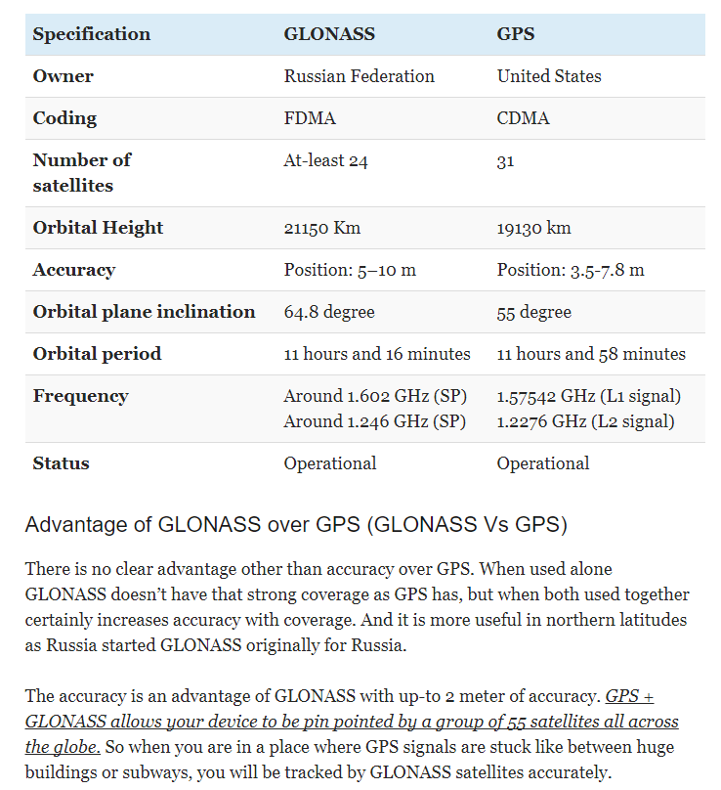
There is also Galileo, the European version of GPS and BeiDou, the Chinese version of GPS and IRNSS, the Indian Regional Navigation Satellite System.
Positioning and location is also available from other MEO constellations (O3b) and LEO constellations courtesy of their strong Doppler signature and (relative to GPS) high flux density. The Iridium Next constellation service offer includes positioning, timing and authentication to Augment GPS Technology for Critical Applications.
Augmented GPS is also available from the Japanese Quazi Zenith constellation, initially from three geosynchronous satellites and one geostationary satellite (Mitchibiki) all broadcasting same L1to L6 signals as GPS and other GNSS systems.
Note that being geo synchronous rather than geostationary means that the satellites progress in a figure of eight pattern over Japan.
Figure 7.36 Quazi Zenith Constellations
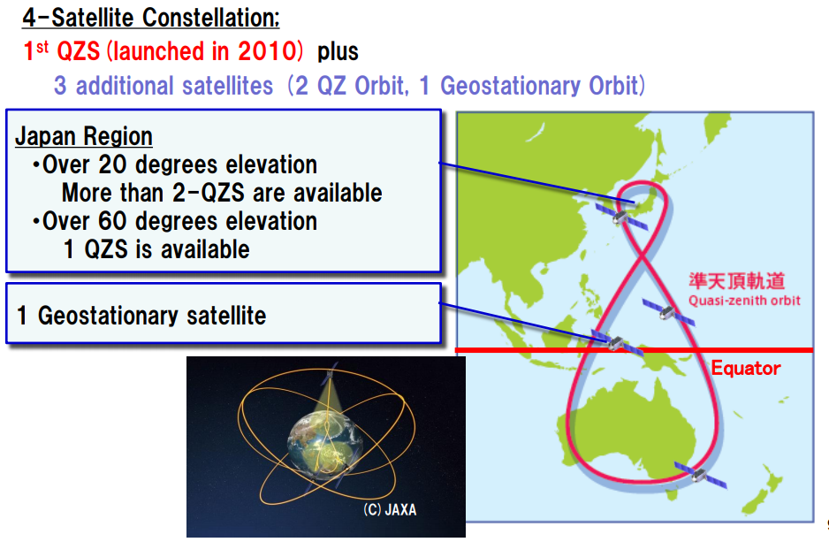
7.12 Orbital Debris
More than 500,000 pieces of debris or ‘space junk’ are tracked as they orbit the Earth. This debris can travel at speeds up to 17,500 mph, fast enough for a relatively small piece of orbital debris to damage a satellite or a spacecraft. The rising population of space debris increases the potential danger to all space vehicles. Such debris includes non-functional spacecraft (Sputnik I is still up there), abandoned launch vehicle stages, mission-related debris and fragmentation debris. Old satellites can contribute substantial debris fields if any hydrazine propellant is not vented at end of life - eventually (through collision with debris or by repeated thermal cycling) the fuel tanks fracture explosively.
There are 500,000 pieces of debris the size of a marble or larger, and many millions of pieces of debris that are so small they can’t be tracked. Even tiny paint flecks can damage a spacecraft when traveling at these velocities (space shuttle windows have been replaced because of damage caused by pain fleck impacts).
There is relatively little debris in GEO and MEO orbits, but substantially more in LEO orbits. Two major events substantially increased the amount of LEO orbital debris:
On Feb. 10, 2009, a defunct Russian satellite collided with and destroyed a functioning U.S. Iridium commercial satellite. The collision added more than 2,000 pieces of trackable debris to the inventory of space junk.
China's 2007 anti-satellite test, which used a missile to destroy an old weather satellite, added more than 3,000 pieces to the debris problem.
Objects are now being actively tracked by a number of dedicated radars around the world, with satellite operators being informed of potential collisions. The position of the International Space Station is regularly adjusted to avoid potential collisions with larger items.
Geostationary satellites are spaced just over 75 km apart and debris-related failures are rare (once every decade). Older spacecraft are ‘parked’ at a higher orbit to avoid potential collisions (and to allow their orbital slot to be reused).
NEWLEGACYLEOs have typically lost a satellite once every three years but the satellites are usually backed with spare satellites in a lower back up orbit.
The risk of more collisions will clearly increase with the projected substantial (x3?) increase in LEO satellite deployments, and debris management will become significant and a potential cost overhead for the NEWLEO operator community.
Guidelines have been proposed to ensure that satellites at the end of their lives can be vented (‘passivated’), and either deorbited in a controlled fashion (ideally for LEO satellites to burn up in the atmosphere, although this isn’t necessarily possible with larger satellites), or placed in ‘safe’ orbits. The majority of nations launching satellites (and the UK) have now signed up to these: however China is not a signatory.
Initiatives to actively reduce the amount of space debris have been proposed by a number of organisations, and ESA (the European Space Agency) is active in this field. This is rather similar to the problem of dumping plastic at sea over several decades. It is a cumulative problem with a solution that requires everyone who has contributed to the mess to help clear it up which is unlikely to happen.
Figure 7.37 Computer generated image of space debris showing concentrated debris in GEO, MEO and LEO orbits
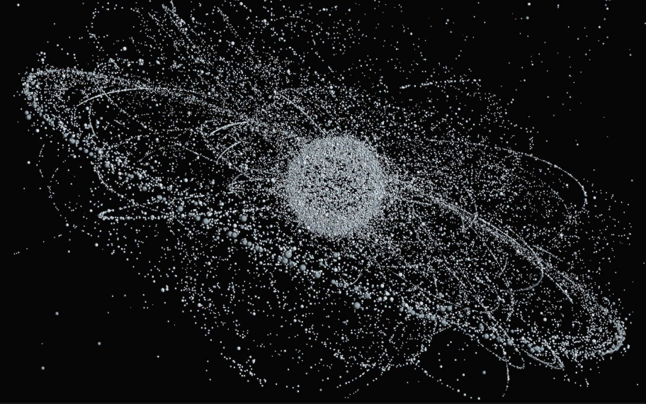
7.13 Sub Space High Altitude Platforms (HAPS)
I am not too sure that High Altitude Platforms belong in a Chapter on Constellation innovation but cannot think where else to include them and given that they fly around above terrestrial networks and below space networks and potentially share the same spectrum then they are definitely part of the overall system to system interference story that we have been teasing out.
The sector divides into heavier than air (HTA) which includes the Aquila drone developed by Facebook. The drone flies at between 60,000 and 90,000 feet (above the weather).
7.13.1 Heavier than Air Facebook Aquila Drones
Figure 7.38 Announcement of first test flight of Facebook Aquila Drone July 2017
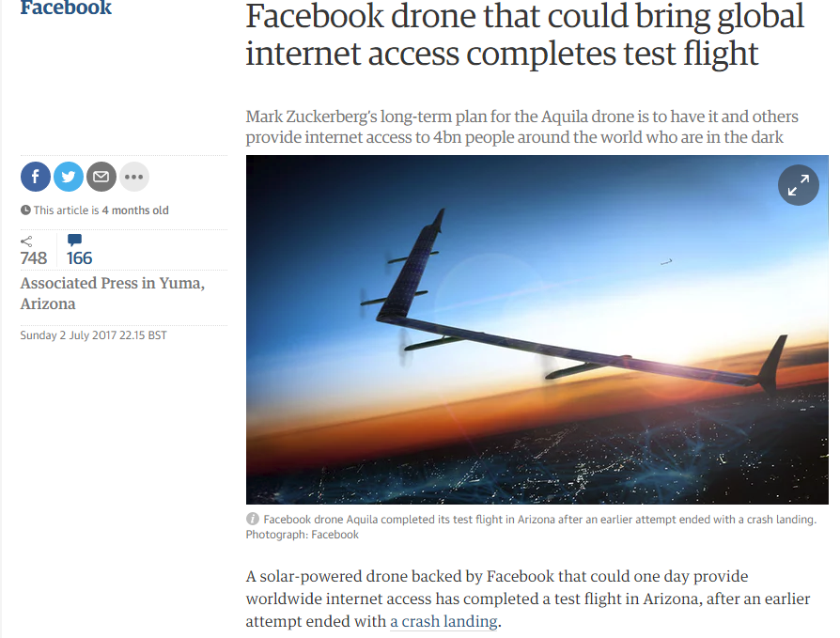
The plane has a wingspan rather wide than a Boeing 737 and is intended to provide Wi-Fi connectivity across a 60 mile diameter/30 mile radius cell. It runs on solar power and batteries and needs about 5 kilowatts to keep it up in the sky providing downwards RF power. It is planned to remain air born for 90 days at a time or longer if possible as landing and taking off is hard work and perilous for what is essentially a fragile piece of machinery. It travels at a stately 80 miles per hour mainly in circles.
Figure 7.39 Aquila Vital statistics

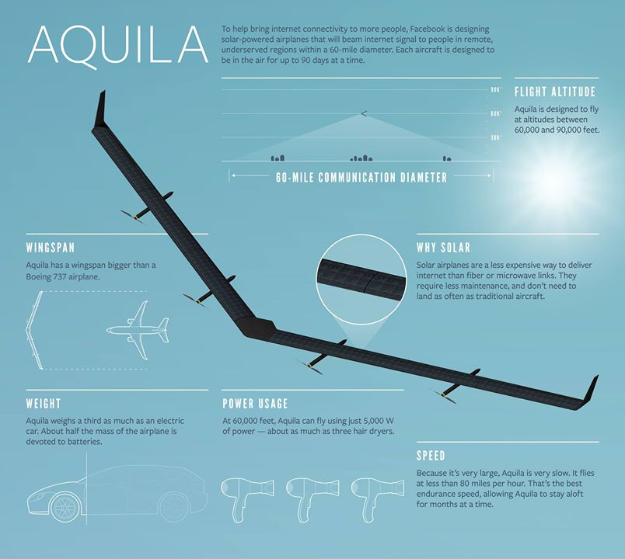
7.13.2 Lighter than Air Platforms
Lighter than Air platforms include updated versions of the R101 and Zeppelin. This includes products such as the Airlander and Lockheed’s helium airship.
Figure 7.39 Airlander flight in the UK
Figure 7.40 Lockheed Helium Airships
These are intended as multipurpose platforms carrying people and materials to remote places quite slowly. They fit in to the category of the Internet of Large Slow Moving Objects so could plausibly become part of an overall integrated communications platform though weather can be quite a problem.
Arguably the highest profile experiments have been with balloons under the Google Loon project. Like the Aquila drones they are designed to fly above the weather at around 60,000 feet.
Figure 7.41 Google Loon Balloon
7.14 Summary
Adding all the FCC filings together produces a grand total of over 10,000 NEWLEO satellites planned for launch into a bewildering selection of low earth orbits with the satellites scaling from a few kilogrammes to 1000 kilogrammes. The overall aim is to replicate the high throughput service offers from incumbent GSO operators in Ku, K and Ka- band and provide a path to very high throughput service offers in V and W band. High latitude coverage will also be better than GSO.
This performance leap is to be achieved by using the same spectrum as the GSO operators typically 3.5 GHz+3.5 GHz pass bands in Ka band or potentially 5GHZ +5 GHz pass bands in V and W band (E band) combined with a high count constellation with each constellation supporting hundreds or potentially thousands of satellites.
This seems like a wondrous prospect though of course even thousands of satellites is a numerically small number compared to the millions of installed LTE base stations (Huawei claim to ship over 1 million LTE base stations per year).
Interestingly this is probably all very technically possible and at least some of the constellations could be financially viable. The main barrier to deployment is not technical but regulatory and revolves around the knotty subject of interference mitigation and protection ratios.
There are technical solutions to interference management but they have an associated cost. High GSO protection ratios will mean that NEWLEOS will need to reduce output power and deliver downlinks at non-optimum elevation angles with long path lengths through the atmosphere. This will reduce throughput and capacity and introduce additional latency all of which will reduce the viability of the NEWLEO constellation offer.
Ultimately this can probably only be resolved by creating corporate entities who either own or have access to all of the constellation options including LEO, MEO, GSO and 5G terrestrial integrated with 2.4 GHz and 5 GHz Wi-Fi but this requires a substantive shift in competition policy across all addressable geographic and vertical markets
The emergence of sub space options such as the Facebook drone project and Google Loon project demonstrate that the GAFA quartet (Google, Apple, Facebook and Amazon) have an appetite for investing in non-traditional connectivity platforms. This is coupled with their developing appetite for launch technology investment (See previous chapter).
The GAFA quartet and other web scale companies have two other significant advantages - cash and customers. This crucially introduces scale into the constellation investment equation, the focus for our next two chapters.

http://www.unoosa.org/pdf/limited/c2/AC105_C2_2014_CRP15E.pdf
http://spacenews.com/three-orbcomm-og2-satellites-malfunctioning-fate-to-be-determined/
https://www.orbcomm.com/en/company-investors/news/2017/orbcomm-acquires-inthinc
In fiscal 2016/2017 Orbcomm generated $57 million in revenue, a 13.8 percent year over year increase, and gained 62,000 net subscribers. The company’s total billable subscriber count reached 1.83 million, up 10.8 percent from the previous year’s 1.65 million.
https://www.fcc.gov/document/fcc-grants-oneweb-us-access-broadband-satellite-constellation
https://www.o3bnetworks.com/wp-content/uploads/2015/02/O3b-Technology-Overview-A4_10SEP14.pdf
http://spacenews.com/oneweb-gets-slide-decked-by-competitor-at-casbaa/
http://www.absatellite.com/company/corporate-overview/
http://www.casbaa.com/
- http://www.eutelsat.com/en/services/data/consumer-broadband/tooway.html
https://www.planet.com/products/satellite-imagery/rapid-eye-basic-product/
www.gps.gov/systems/gps/space/
https://beebom.com/what-is-glonass-and-how-it-is-different-from-gps/
Quazi zenith is the term used to describe geosynchronous as opposed to geostationary orbits
http://qzss.go.jp/en/
https://www.facebook.com/notes/mark-zuckerberg/the-technology-behind-aquila/10153916136506634/
http://www.airshipsonline.com/airships/r101/Crash/R101_Crash.htm
http://www.airships.net/zeppelins/
https://www.hybridairvehicles.com/
http://www.lockheedmartin.co.uk/us/products/HybridAirship.html
https://x.company/loon/

